Hannah Moore
HOW TO WEAR AND USE A CIVILIAN MASK
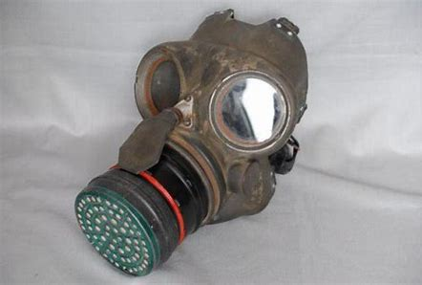
Everyone in Britain got a gas mask in a little cardboard box to protect them from gas bomb. When you breathed in the air went through the filter and when you breathed out the mask went a little bit away from your face to let the air out.
1.Pull the mask over your head with the strap going all around the back of your head.
2.Twist the end of the mask until you can breathe nice and clean air and then breath normally like would do on a daily basis.
3.Make sure the mask is securely on your face, if it` s to bagie tighten the back of the strap until it is secure.
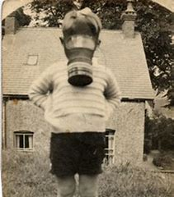
4.When the bombing is over DO NOT take it of just in case there is any more bombs coming or there is still gas in the air.
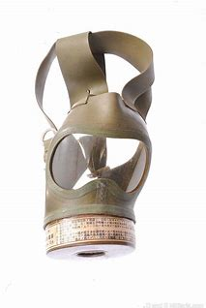
5.When the army or the police say you can take of your mask then do so but make sure to wear it at night just in case they bomb again when your asleep.
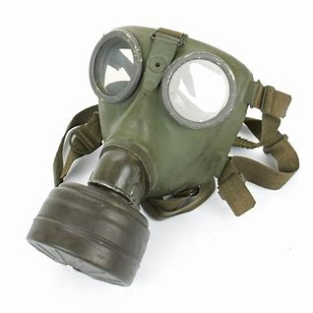
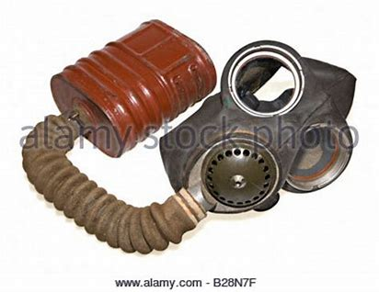
There are a lot of different types of gas masks like the ones below.

In ww2 the gas mask really helped a lot of people, the first gas bomb drop in WWII was in Scotland October 16th 1939. Many had gas masks but many suffocated because they weren`t wearing their mask. Top of Form

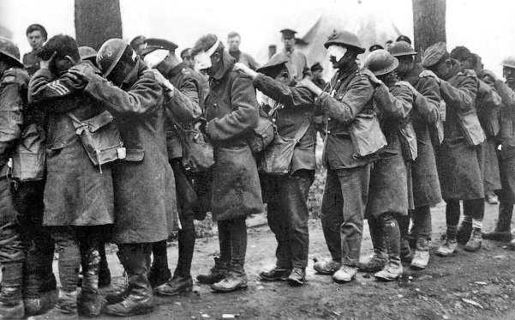
The first bombing in WWII was in Scotland October 16th, many survived thanks to the gas masks however quite a lot of adults and children suffocated because they didn’t have a gas mask on. The British official history started that at hill ,60 “90 men died from gas poisoning in the trenches or before they could get a dressing station; of the 207 brought to the nearest dressing station, 46 died almost immediately and 12 after long suffering.

