Maths Transition:

MEI's Calculator Crunch
The Calculator Crunch is a fun way to continue to engage Year 6s with maths whilst also developing their confidence with calculators, ready for maths at secondary school.

The activities in the challenge provide extra practice for Year 6s and 7s in key areas of the maths curriculum.

Parents and carers can use the challenge activities with their children at home, and teachers can incorporate them into work they are setting for pupils either in school or remotely.

Since calculators are no longer needed for KS2 SATs, their use has not been such a key focus in primary schools.

The aim of the challenges below (taken from MEI’s 2019 Calculator Crunch) are to make sure pupils are more familiar with calculators and ready to use them as they start secondary school.

The activities can be done using basic calculators or scientific calculators which pupils will be encouraged to use as they start Year 7.

Each challenge has its challenge page and then a help page to offer assistance to parents, carers and teachers.

The calculators we currently recommend at Fallibroome are the CASIO FX-83GTX & FX-85GTX or the now discontinued FX-83GT PLUS & FX-85GT PLUS, but any modern scientific calculator will be fine for secondary school if you already have one.

: CHALLENGE 1

- Who’s the BOSS! -
Type 5508 into your calculator and turn it upside down.
What are you?

Your challenge is to find 10 different ways of creating 5508 using the calculator. Be creative and find the most interesting way to write BOSS.
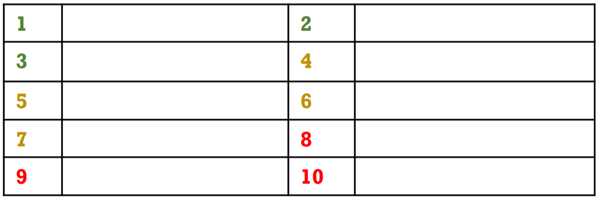
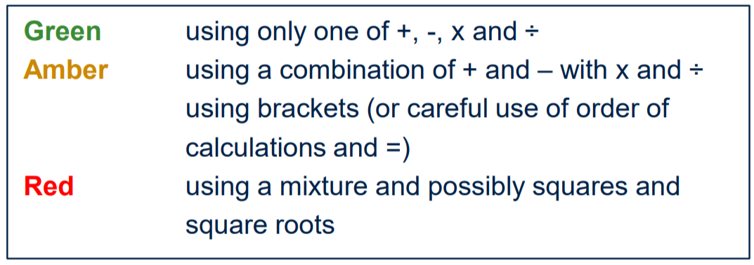

: HELP 1

- Who’s the BOSS! -

Aim of the game
To create different calculations which equal 5508 and to be as creative as possible with the numbers and operations (+ − × ÷ √ etc.)

How to play
Use any calculator you have at home, on a computer or on a phone.

How many different calculations can you find which have the answer 5508?

5500 + 8 is a start but can you be more creative?

Can you use × and ÷ calculations?
Can you use a mixture of operations + − × ÷?
Can you use squares and square roots?

The Green, Amber and Red ideas might help you to think of other possibilities.
Green – using only one of +, −, × and ÷
Amber – using a combination of + and − with × and ÷ – using brackets (or careful use of order of calculations and =)
Red – using a mixture and possible squares and square roots

You don’t have to stop at ten different ways!

Using the calculator?
Does it matter which order you enter the calculations?

Top Tips
In Year 6, children learn about BODMAS or BIDMAS which helps them to remember
the order of operations:
B – brackets
O/I – indices (powers)
D and M – division and multiplication (left to right)
A and S – addition and subtraction (left to right)
If you use a scientific calculator then it will automatically apply this rule.
A basic (four operation) calculator will not. If you have both then it is interesting to compare
the answers when you enter the same calculation into each.

: CHALLENGE 2

- The Day the Numbers Left -
Which calculation do you need to enter into the calculator to work out the missing number?
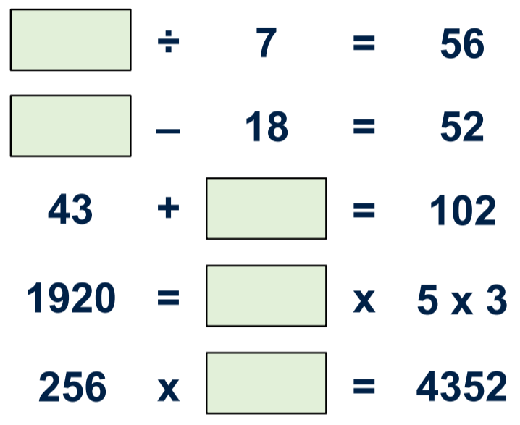 | Remember to show the calculations you’ve done, rather than just the number.  Extra: Are there any that you can solve in more than one way?  If you enjoyed this activity then you might like:  Funny Factorisation from NRICH (nrich.maths.org/740)

: HELP 2

- The Day the Numbers Left -

Aim of the game
To work out what to enter into the calculator so that the answer is the number that you need to write in the green boxes
e.g. to solve × 3 = 36 you would need to enter 36 ÷ 3 = into the calculator to get the answer 12, which is the number that goes in the green box to make the calculation (or equation) correct.
You would record: 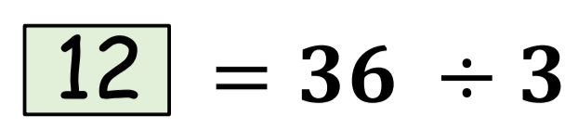

How to play (using a calculator)
Look at the calculation (or equation) with the number missing from the green box.
Work out what calculation you need to do on the calculator to work out what the missing number is. Record the calculation here:

Challenge
Are there any that you can solve in more than one way?

Top Tips
You need to think about using the inverse (opposite) but think carefully especially when the question involves × and ÷.

: CHALLENGE 3

- ORDER! ORDER! -

2 x 100 – 60 + 40 2 x 100 – 40 + 60

Which symbol goes between these two expressions:
, ^{or}

<

>

=
Can you use brackets below to find ways where each symbol could be used?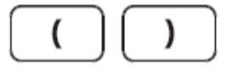

Is there more than one way to do it?

2 x 100 – 60 + 40 > 2 x 100 – 40 + 60

2 x 100 – 60 + 40 > 2 x 100 – 40 + 60

2 x 100 – 60 + 40 > 2 x 100 – 40 + 60

: HELP 3

- ORDER! ORDER! -

Aim of the game
To use brackets in different places and the rules of BODMAS to change the value of an expression (a calculation without an = sign).
For example, (2 × 100) − 60 + 40 = 180 but 2 × (100 − 60) + 40 = 120
In Year 6, children learn about BODMAS or BIDMAS which helps them to remember the order of operations:
B – brackets
O/I – indices (powers)
D and M – division and multiplication (left to right)
A and S – addition and subtraction (left to right)

The challenge is to use brackets so that each of these could be correct:
2 × 100 − 60 + 40 > 2 × 100 − 40 + 60
2 × 100 − 60 + 40 < 2 × 100 − 40 + 60
2 × 100 − 60 + 40 = 2 × 100 − 40 + 60

This > that means - This ‘is greater than’ that
This < that means - This ‘is smaller than’ that

How to play
A scientific calculator always follows the rules of BODMAS but a basic calculator will complete the calculations in the order that you enter them. You will need to use the bracket keys on both calculators to make sure that you get the answer you are expecting. It is a good idea to work the answer out in your head to make sure that the calculator is doing what you want it to!

Challenge
Are there any that you can solve in more than one way?

Top Tips
Remember BODMAS
Use the bracket keys on the calculator carefully
Work it out without using the calculator as well to check

: CHALLENGE 4

- Race to 30 -
How can you always win this game?
Play in pairs. Each player starts with zero.
Take it in turns to choose a number to add to your total.
Each number can only be used once, and only by one player!

The winner is the first person to make the display show 30. If you go over 30, you lose!

You can always win at Race to 30 if:

There are other number strategy games on the NRICH website (nrich.maths.org/1209/index)

: HELP 4
- Race to 30 -

Aim of the game
To use addition with small numbers to make the total of 30 and no more!

How to play
You need to play this game with someone and you will need a calculator each.

Take it in turns to choose a number. Each number can only be used once.

When you choose your second number, add it to the first Keep the total on your calculator and keep adding the next number.

To win you need to get your total to exactly 30 If you go over 30, you lose!

Challenge
Is there a strategy so that you can always win?
Is it best to go first or second?
Can you come up with a winning strategy and explain it here?

Top Tips
Any calculator will do for this activity as you are only adding.
You might need to play the game a few times to work out your strategy.
Take turns to be player 1 and player 2.

: CHALLENGE 5

- Halfway There! -
Choose four numbers from 1 to 9:
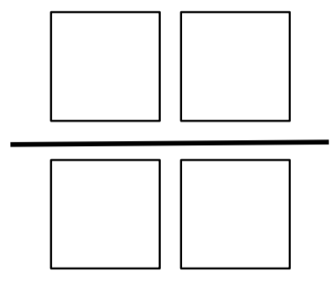

Place them in the boxes to make a fraction.

Which arrangement of your four numbers gives a value closest to a half?

The four numbers I chose were:

This arrangement is closest to a half:

To get close to a half you need to:

: HELP 5

- Halfway There! -

Aim of the game
You are trying to make fractions which are as close to a half as possible.

How to play
Divide a sheet of paper into nine pieces and write the digits 1 to 9 on the pieces. (You could use ace to 9 from a pack of playing cards)
Choose 4 of the cards. Use the 4 cards to make two 2-digit numbers.
Make a fraction using one number as the numerator (top number) and the other one as the denominator (bottom number).
You could put them in the fraction template How will you know if the fraction is close to a half?

Top Tips
In all fractions equal to a half, the numerator (top number) is half the value of the denominator (bottom number) e.g. 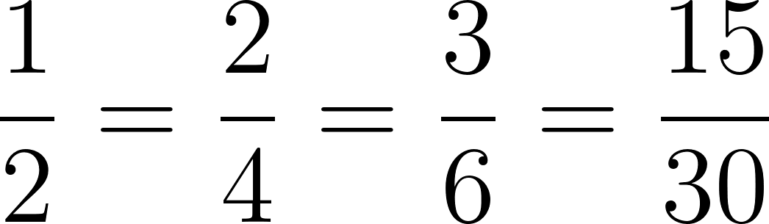 etc.

How can you use a calculator to check that the fraction is close to a half?
Fractions are divisions so if you divide the numerator (top number) by the denominator (bottom number), the answer will be that fraction as a decimal.
Try it with 1 ÷ 2 = 0.5
0.5 is a half as a decimal so you are trying to get as close to 0.5 as the answer to your division.
For example, with the cards 1, 4, 7 and 9 you could make 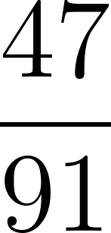 and 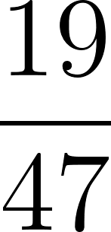.
47 ÷ 91 = 0.516 and 19 ÷ 47 = 0.404 (the decimals are rounded to three decimal places).
We can either subtract 0.5 or take a smaller amount away from 0.5 to work out how close the fraction is to half. 0.516 – 0.5 = 0.016 and 0.5 – 0.404 = 0.096 away from 0.5.
so is closer to a half.

What else could you do?
You could try making fractions close to or .
How close can you get to a fraction which equals 1 whole?

: CHALLENGE 6

- Take 5 (Keys) -
Choose 3 digit keys and 2 operation keys e.g.
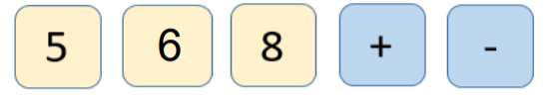
You can always use the = key.
Can you make all the numbers from 1 – 20 using only these keys?
You can use the keys as often as you want each time.

I used these keys:

1 |  | 11
2 |  | 12
3 |  | 13
4 |  | 14
5 |  | 15
6 |  | 16
7 |  | 17
8 |  | 18
9 |  | 19
10 |  | 20

Things to think about…
Can you use the difference between the numbers to help?
Can the way you made a number before help you this time?
Extra challenge
What if you ‘Take 4’ and use 2 digits and 2 operations?

: HELP 6

- Take 5 (Keys) -

Aim of the game
To create calculations to equal all the numbers from 1 to 20 but using only 3 digit keys and 2 operation keys. You can always use the equals key!

How to play
Choose three numbers to use and 2 operation keys (+, -, × or ÷).
Using just those keys, create calculations that equal the numbers from 1 to 20.
e.g. using 5, 6, 8, + and – you could make the answers 1, 2 and 3 like this:
6 – 5 = 1
8 – 6 = 2
8 – 5 = 3
What will you do to get the answer 4?
Could you use + and – in the same calculation?
6 + 8 – 5 = …?
You could draw a table to record your calculations

Using the calculator?
Does it matter which order you enter the calculations?
Does 6 + 8 – 5 = give the same answer as 8 – 5 + 6 = ?
What if you chose × and ÷ as your operation keys?
Does the order you enter the calculation matter?

Top Tips
In Year 6, children learn about BODMAS or BIDMAS which helps them to remember
the order of operations:
B – brackets
O/I – indices (powers)
D and M – division and multiplication (left to right)
A and S – addition and subtraction (left to right)
If you use a scientific calculator then it will automatically apply this rule.
A basic (four operation) calculator will not. If you have both then it is interesting to compare
the answers when you enter the same calculation into each.

: CHALLENGE 7

- Mystery Number -
What could this number in your display mean and how might it have got there? What would it mean if it was:
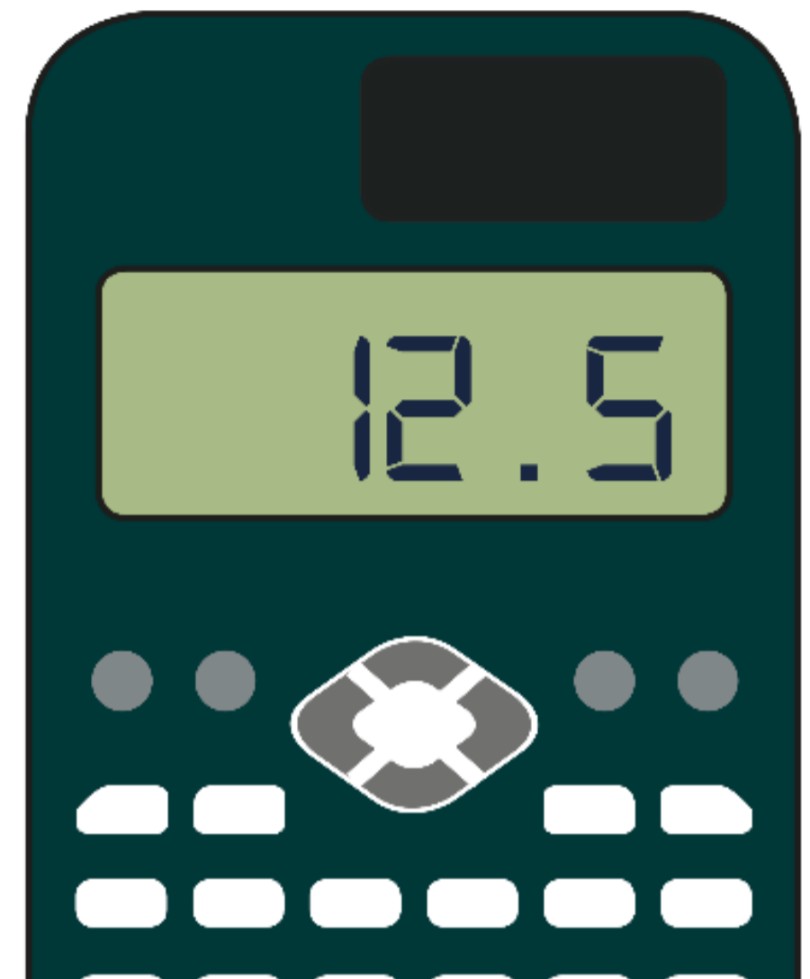
- Time – days, hours, minutes, seconds
- Money
- Length
- Mass
- Capacity … or …

12.5 could be:

: HELP 7

- Mystery Number -

Aim of the game
To work out what 12.5 might mean as the answer to a problem.
Calculators are great at doing calculations, but they don’t always tell us what the answer means.
The answer the calculator has given us is 12.5 but what could that mean?

How to play
Think of all the different things that the question could have been about. Here are a few examples:
What would it mean if it was:
- Time – days, hours, minutes, seconds?
- Money?
- Length?
- Mass?
- Capacity?
For example, if it was 12.5 hours, the display would mean 12 hours and 30 minutes as 30 minutes is half an hour or 0.5 of an hour.
What would it mean if the problem was about money and the 12.5 was pounds (£)? What else could you have been working out?

Top Tips
0.5 is a half 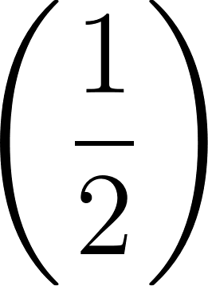 as a decimal so think about what a half means in different situations.

: CHALLENGE 8

- Equivalence is Key -
If I know that 482 x 75 = 36,150
What do I need to insert in each row to make the expressions equivalent? For example:

4820 x 75 = 482 x 75
482 x 7.5 = 482 x 75
4820 x 7.5 = 482 x 75
48.2 x 7.5 = 482 x 75
482 x 750 = 482 x 75
48.2 x 75 = 482 x 75

What other expressions can you write that are equivalent to
48.2 x 7.5?

: HELP 8

- Equivalence is Key -

Aim of the game
To work out which operation and number are needed to make the two sides of the calculation equal.

The operation will be either × or ÷
The missing number will be a multiple of 10

In the first example:
4820 × 75 = 361,500
482 × 75 = 36,150
36,150 × 10 = 361,500
So to make them equal, we need to multiply the second part by 10 so that
4820 × 75 = 482 × 75 × 10

How to play (using a calculator)
Use the calculator to work out what each side is equal to and then compare the answers to see what you need to do to make them equal.
Use the calculator to check.

What other expressions can you write that are equivalent to 48.2 × 7.5?

Top Tips
Think about what happens to numbers as we × and ÷ them by 10, 100 and 1,000.
The digits move as they become 10/100/1,000 times bigger and smaller. Thinking about the place value headings might help.
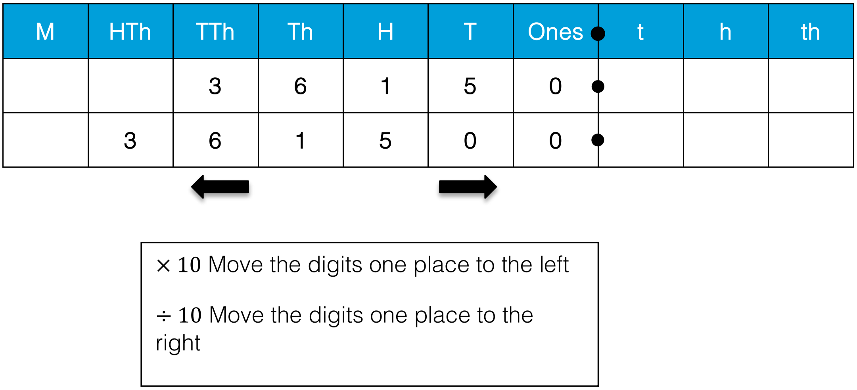

: CHALLENGE 9

- A-Maze-Ing -
Start with the number 2 on your calculator.
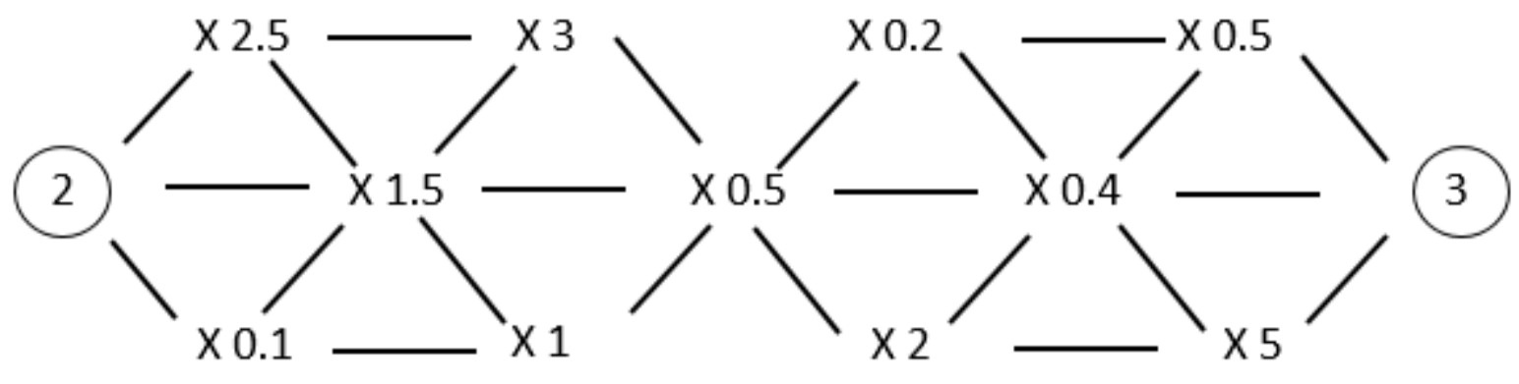
Find a route through the grid, travelling only once along a line, so that you end up with a 3 on your display.

Is there only one way to do it? How can you be sure?

Can you go back from right to left, starting with 3 and finishing with 2?

My solution:

2 x = 3

If you enjoyed this activity then you might like:
The Money Maze from NRICH (nrich.maths.org/2648)

: HELP 9

- A-Maze-Ing -

Aim of the game
To work your way across the maze doing the calculations and ending up with the answer 3 on your calculator.

Start with 2 and do the 3 possible first calculations.

2 × 2.5 =
2 × 1.5 =
2 × 0.1 =

What do you notice?
Does multiplication always make the answer bigger?
This activity is all about thinking about what happens when you multiply by less than 1.
If you multiply by less than 1 then you will have less than 1 times what you started with, and so the answer will be smaller.

How to play
Use the calculator to work your way across the maze in a way that you end up with the answer 3 after your last step.

Top Tips
Choose your next step by thinking about whether you need to make your answer bigger or smaller.

An expression is a collection of values and operations (+ − × ÷) which do not have an = sign. So 2 × 100 − 60 + 40 is an expression.

