Home Learning for the week beginning 15th June 2020 Class 1DW 1KMR
Below is a set of activities linked to the topic in the centre. Have a go at as many of these as you can and send us a picture of some of your work. Have fun! PHONICS – you can keep up to date practicing your phonics daily by watching these online lessons https://wandleenglishhub.org.uk/lettersandsounds/year-1
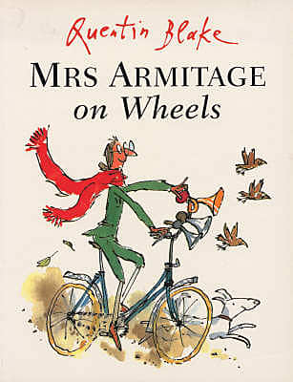  Watch and retell the story. https://www.youtube.com/watch?v=BL_JIl9V16s | What did Mrs Armitage’s bike need?  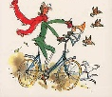  Can you remember and list the things from the story in the correct order in which they occurred?  If you would like why not draw a picture of the bike to show what it looked like just before it broke. | Can you discover all the different types of transport that exist and put them into the following categories…  Land Sea Air  You can draw pictures and/or write them down. | 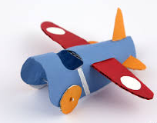  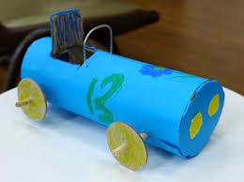  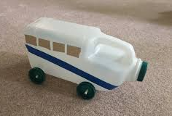  Make a form of transport using junk modelling or anything around your home. Something for one of your teddies to travel in.
Design your own bicycle.  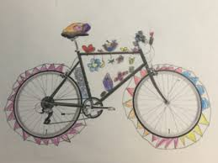  What would you need on your bicycle?  https://www.twinkl.co.uk/resource/t2-pe-61-design-your-dream-bicycle-activity-sheet | 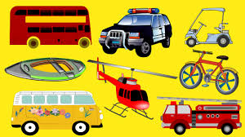  Transport |  | Do you have any toys at home which are forms of transport?  Can you measure these in centimetres using a ruler or tape measure and compare the length of what you have?  You could even draw some different forms of transport which you could measure too.  If you don’t have a ruler ask your grown up at home if they can make you one out of paper?
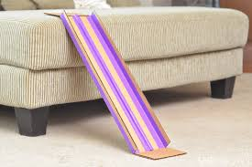  What happens when you  send a toy car down  a ramp?  Make a ramp at home and find out. Try different sized cars. Measure the distances they travel and discuss results. Do the larger ones go further than the smaller ones? If so why? Can you make the car go even faster? If so, how did you do this? | 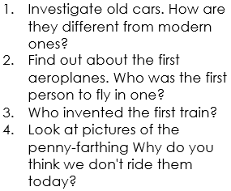  Do some researching online  on Kiddle with a grown up…  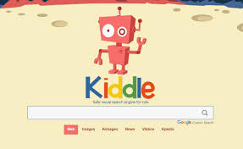  and answer the following questions… |  | Can you go for a walk and find a busy road?  Look out for the different forms of transport you may see?  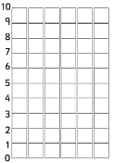  Make a traffic survey? Record your results using a pictogram or bar chart?  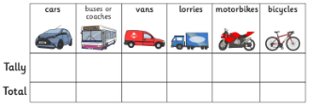
Below are some links to resources online you may find useful.
Listen to the story https://www.youtube.com/watch?v=BL_JIl9V16s
Transport PowerPoint Presentation https://www.twinkl.co.uk/resource/t-t-5288-transport-video-powerpoint
Transport word mat https://www.twinkl.co.uk/resource/t-t-181-transport-word-mat
Transport Quiz https://www.twinkl.co.uk/resource/t-t-9035-what-type-of-transport-powerpoint-quiz
Design your own bicycle https://www.twinkl.co.uk/resource/t2-pe-61-design-your-dream-bicycle-activity-sheet
Transport dot to dot https://www.twinkl.co.uk/resource/t-t-4961-transport-dot-to-dot-activity-sheets
Traffic pictogram and bar chart https://www.twinkl.co.uk/resource/t-he-051-traffic-survey-and-bar-chart-activity
I Spy Activity https://www.twinkl.co.uk/resource/t-t-19871-transport-i-spy-scene-activity
Printable Ruler https://www.twinkl.co.uk/resource/t-n-4863-25-centimetre-ruler-cut-outs
Transport Old and New PowerPoint https://www.twinkl.co.uk/resource/t-t-4886-transport-old-and-new-photo-powerpoint
Daily PHONIC lessons https://wandleenglishhub.org.uk/lettersandsounds/year-1
Stories you may enjoy.
Mr Gumpy's Outing J. Burningham
Mr Gumpy's Motor Car. J. Burningham
Bears on Wheels. Stan and Jan Bernstein
Mrs Armitige Queen of the road.. Quentin Blake
Hey Get off our Train! J Burningham
Hop on Pop. Dr Zeus
My Truck is Stuck. Kevin Lewis
If I built a car Chris Van Dusen
Who was Amelia Earhart? Nancy Boehm
Whatever Next? Jill Murphy

